

Joining Main Server to Branch Server, FSRM, DFS Configuration with Windows Server in Sentosa Hospital

Group 2:

|  |  |
| --- | --- |
| Abdur Rashid Firdaus | (2320010109) |
| Ahmad Maulana Ibrahim | (2320010111) |
| Ayunda Pramita Kurnia Hapsari | (2320010189) |

Faculty:

Ivan Firdaus, S.T

Class:

2CS1

CEP CCIT FACULTY OF ENGINEERING UNIVERSITY OF INDONESIA

2024

|  |
| --- |
| **PROJECT INFORMATION** |

|  |
| --- |
| Project Title : Joining Main Server to Branch Server, FSRM, DFS Configuration with Windows Server in Sentosa Hospital  Batch Code : 2CS1  Start Date : July 8th, 2024  End Date : July 17th, 2024  Name of Faculty : Ivan Firdaus, S.T  Names of Developers:   1. Abdur Rashid Firdaus 2. Ahmad Maulana Ibrahim 3. Ayunda Pramita Kurnia Hapsari   Date of Submission: July 19th, 2024 |

|  |
| --- |
|  |

|  |
| --- |
| **CERTIFICATE OF ORIGINALITY**  This is to certify that the project report titled " Joining Main Server to Branch Server, FSRM, DFS Configuration with Windows Server in Sentosa Hospital" is an original work completed by Abdur Rashid Firdaus, Ahmad Maulana Ibrahim, and Ayunda Pramita Kurnia Hapsari. This project has been submitted in partial fulfillment of their course requirement at the National Institute of Information Technology (NIIT).  The project report has been prepared under our research and experiment, and it is ensured that the work presented in this report is the result of the individual efforts of the aforementioned students. The contents of this report have not been submitted to any other institution or organization for the award of any degree, diploma, or other similar recognition.  Authors acknowledge that the ideas, designs, and implementations presented in this project report are the intellectual properties of the students mentioned above. Any use or reproduction of this work must give proper credit to the original authors.  Authors hereby endorse the authenticity and originality of the work presented in this project report and confirm that it meets the academic standards and requirements set forth by the National Institute of Information Technology (NIIT).  Coordinator:  Mr Ivan Firdaus, S.T |

|  |
| --- |
| Author would like to acknowledge the completion of the insightful paper titled " Joining Main Server to Branch Server, FSRM, DFS Configuration with Windows Server in Sentosa Hospital." This paper comprehensively discusses how to configure Joining AD to AD, FSRM, & DFS in the Windows software.  The contents of this paper provide a detailed overview of how to configure various service using windows server. The paper serves as a way of understanding windows server as a subject for this second semester.  Depok, 30 June 2024  Authors |

|  |
| --- |
| For the system in this project, authors create a main server and branch server using the Windows Server operating system. The services that are configured in this project include Joining AD to AD, FSRM, and DFS. The benefit that we can get in this project is that we can configure the server manager in the Windows operating system. Not only that, we can also create our own FSRM and DFS. |

|  |
| --- |
| **SERVICES** |

|  |
| --- |
| 1. **Active Directory Domain Service (AD DS)**   A directory service provided by Microsoft for Windows domain networks. It is included in most Windows Server operating systems as a set of processes and services. AD DS stores information about members of the domain, including devices and users, verifies their credentials, and defines their access rights.   1. **DNS (Domain Name System)**   A hierarchical and decentralized naming system for computers, services, or other resources connected to the Internet or a private network. It translates human-friendly domain names to the numerical IP addresses needed for locating and identifying computer services and devices.   1. **File Server Resource Manager (FSRM)**   File Server Resource Manager (FSRM) is a role service in Windows Server that enables you to manage and classify data stored on file servers. You can use FSRM to automatically classify files, perform tasks based on these classifications, set quotas on folders, and create reports monitoring storage usage.   1. **Distributed File System (DFS)**   A distributed file system (DFS) is a file system that spans across multiple file servers or multiple locations, such as file servers that are situated in different physical places. |

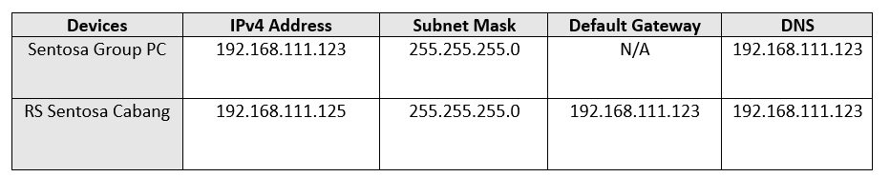

Operating system virtual machine specification :

1. Windows Server 2022 (1)

* 2GB RAM
* 50GB Storages
* 1 CPU
* 1 Internal Network Adapters

1. Windows Server 2022 (2)

* 2GB RAM
* 50GB Storages
* 1 CPU
* 1 Internal Network Adapters

|  |
| --- |
|  |

|  |
| --- |
| **AD-AD CONFIGURATION** |

1. **CREATE AN IP ADDRESS ON BRANCH SERVER**

First, we create an IP address for the branch server by matching the subnet mask. we need to set the DNS IP Address on the branch server according to the main server. Don't forget to turn off all firewalls and change the network to an internal network.

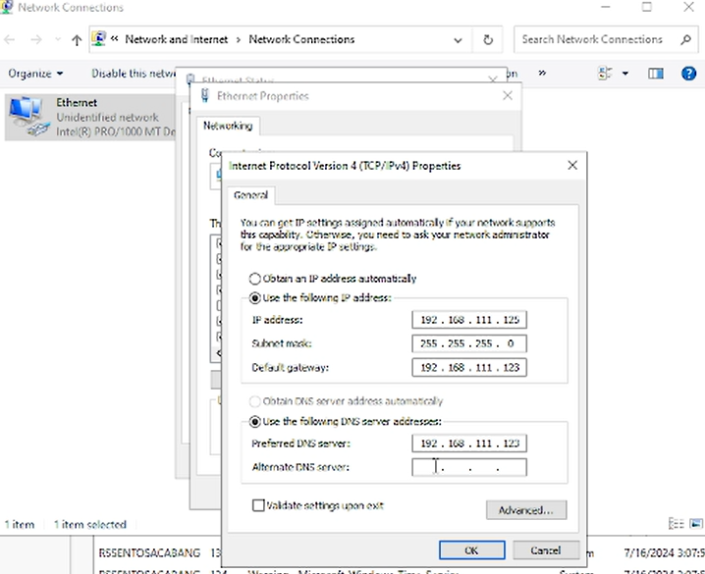

1. **INSTALL ADDS & DNS SERVER ON BRANCH SERVER**

Install the additional ADDS & DNS features on the branch server. Then, we click on the words "Promote this server to a domain controller" to connect the two servers.

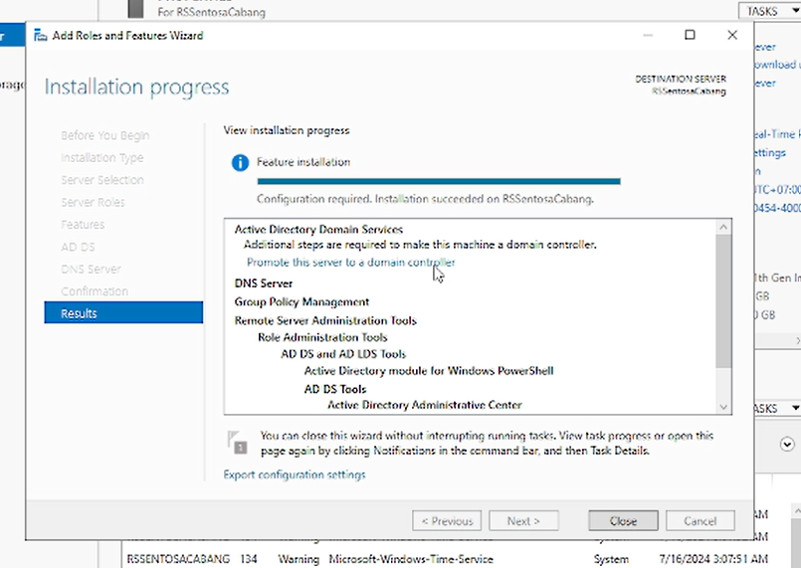

|  |
| --- |
| **AD-AD CONFIGURATION** |

1. **CONFIGURING DNS SERVER ON BRANCH SERVER**

Select the operation section “Add a domain controller to an existing domain”. After that, enter the main server username & password.

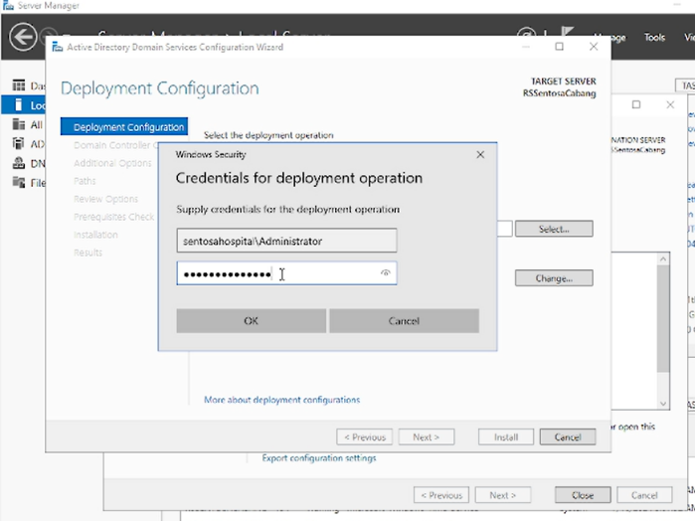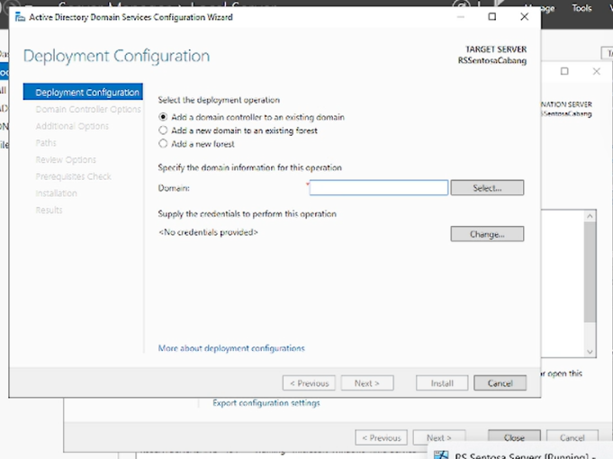

Create a password for DSRM. For the next part, you just need to click next to the end. If the configuration is complete, your computer will restart automatically. If successful, the branch server computer will appear on the main ADUC server in the domain controller section.

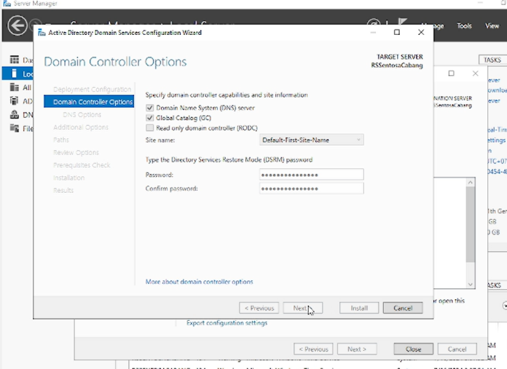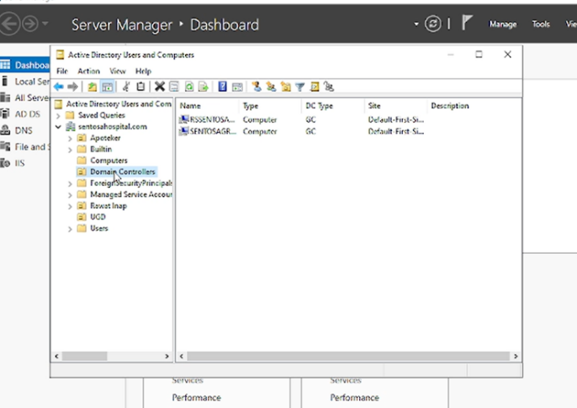

|  |
| --- |
| **FSRM CONFIGURATION** |

1. **INSTALL FSRM SERVICES ON MAIN SERVER**

You need to open the main server, then install the File Server Resource Manager.

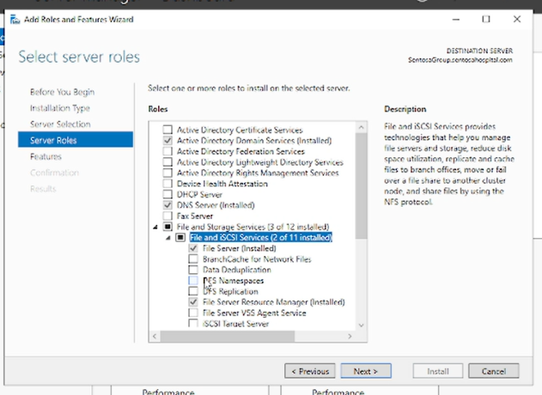

1. **CONFIGURING QUOTA IN FSRM**

First we need to create a Quota Template. Right-click the quota template section, then select “Create Quota Template. Fill in the name of the quota template as you want. Here you can choose the quota limit for a file. Choose the space limit according to what you want.

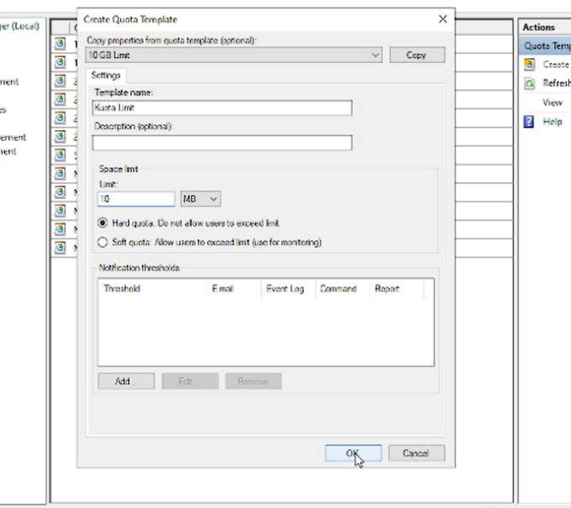

|  |
| --- |
| **FSRM CONFIGURATION** |

After that, we need to right click on the quota section and select "create quota". Then, we need to enter the folder where we want to limit the quota. After that, select the quota template that we previously created. Next, we click "create".

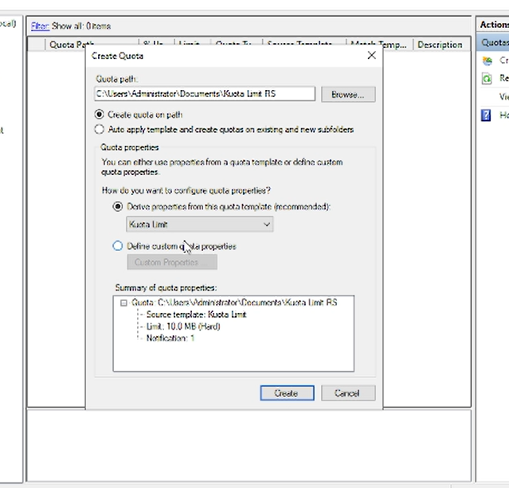

1. **CONFIGURING FILE SCREEN IN FSRM**

Next, we need to create a Screen Template File. Right-click the screen template file, then select “Create File Screen Template. Fill in the name of the screen template file as you lwant. Here you can select the file group that we want to block. Select the file group according to want you want.

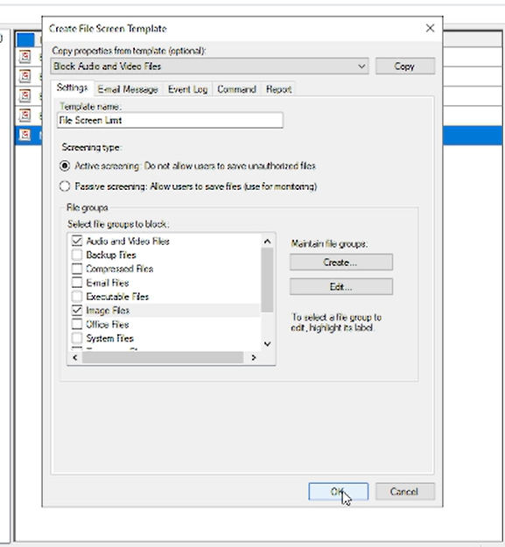

|  |
| --- |
| **FSRM CONFIGURATION** |

After that, we need to right-click the file screen section and select "create file screen". Then, we need to enter the folder where we want to file screen. After that, select the screen template file that we previously created. Next, we click "create".

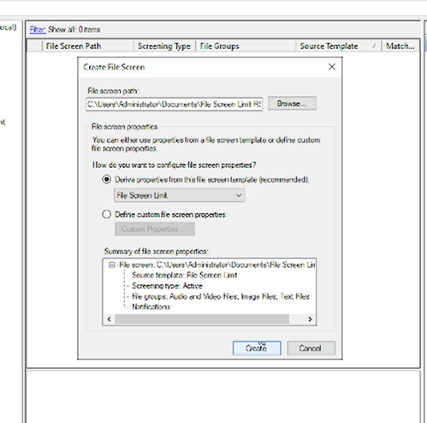

1. **CONFIGURING STORAGE REPORT IN FSRM**

Then, you need to create Storage Reports Task Properties. This is useful for viewing activities that occur in a folder. Right-click the storage reports task properties section. After that, select the “Schedule a New Report Storage” section. Next, you need to complete the configuration such as the name of the report, what data you want to display, and the schedule for updating the report. If successful, you can open the C:/StorageReports/Interactive/ directory and select what data you want to see. Because we chose the schedule report earlier, the data will be updated at the specific time we chose.

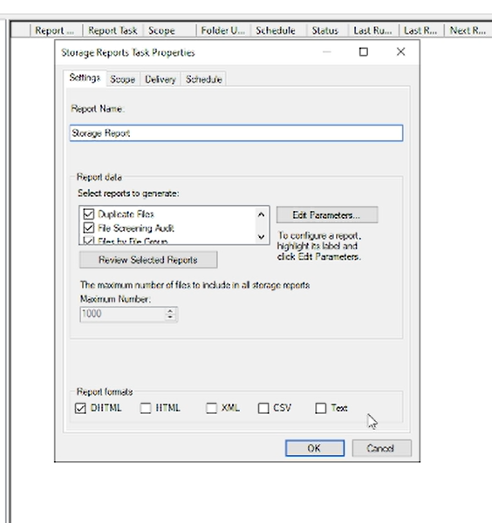 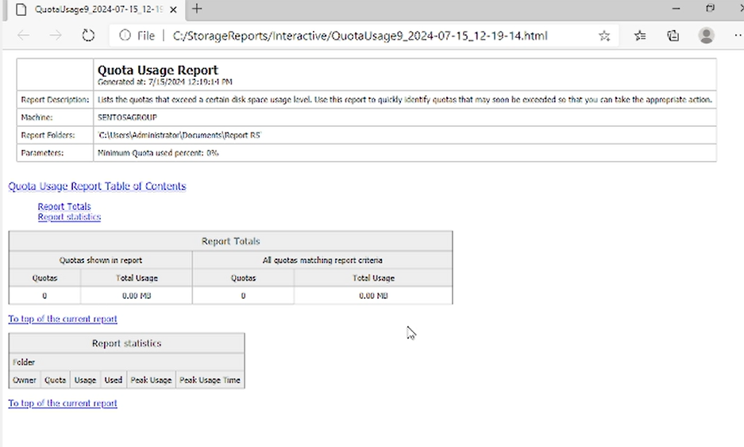

|  |
| --- |
| **DFS CONFIGURATION** |

1. **INSTALL DFS SERVICES ON MAIN SERVER**

First, you need to install the DFS service on the main server.

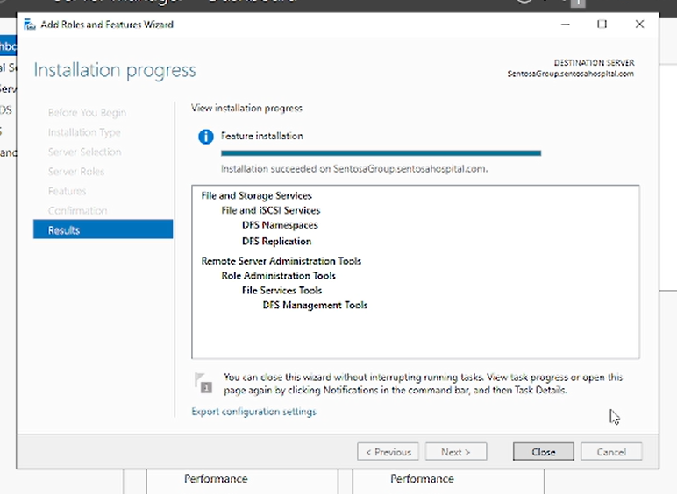

1. **CONFIGURING DFS SERVICE**

Then, you need to open your DFS Management. After that, right-click the namespaces section and click 'New Namespace'. Next, you need to enter the main server in the server namespace section. And next, you can give a name to the namespace that you will create.

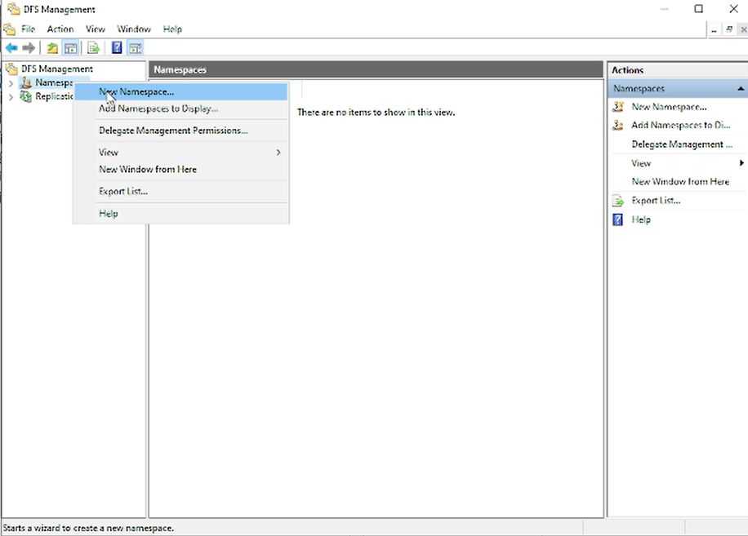 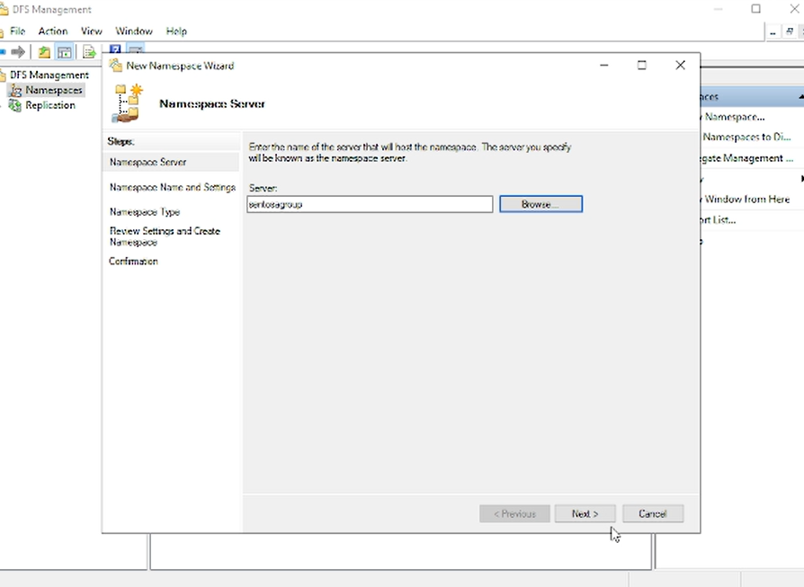

|  |
| --- |
| **DFS CONFIGURATION** |

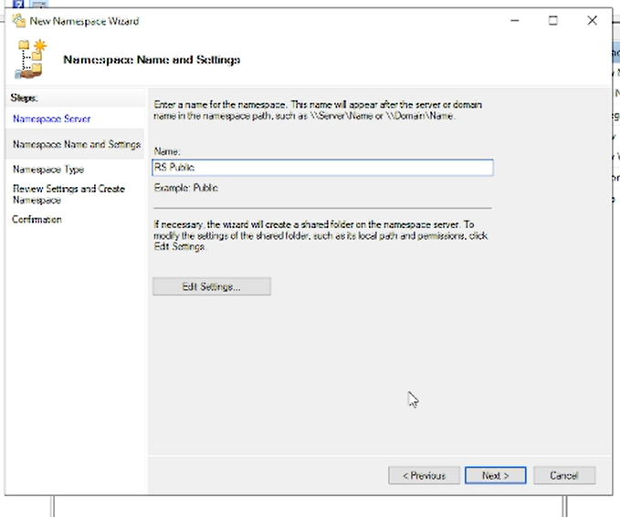

Next, you need to create two folders that you will share. One folder on the main server, and another folder on the branch server. Both folders must have the same folder name. After that, you need to edit the sharing folders section in the properties section. You need to add everyone and change the permissions to Read/Write on both folders.

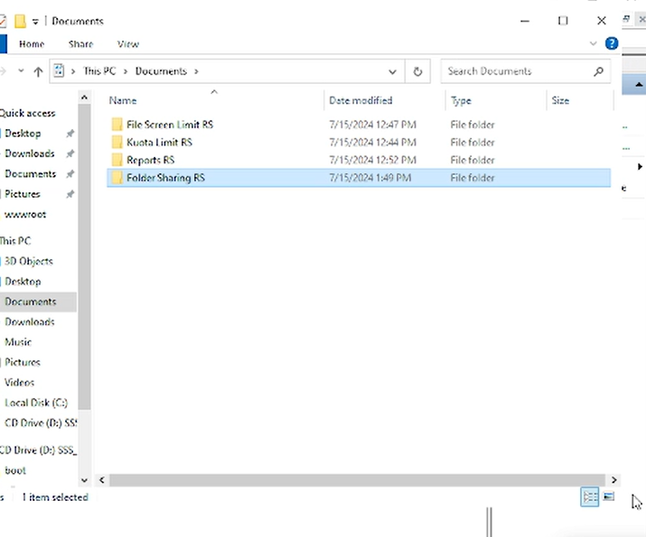 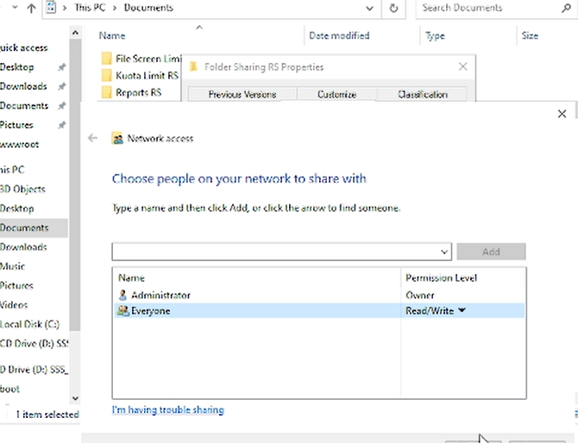

|  |
| --- |
| **DFS CONFIGURATION** |

After that, right-click the namespace that you just created and select "New Folder". Then, you enter the two folders that you just created previously. If so, there will be a replication group notification tone. Click yes, and you will automatically be taken to the replicate folder wizard. Here you only need to fill in the Primary Member with the main server. Then next, click next until the replication folder is successfully created. If successful, when you create or edit a file in one of these two folders, the other folder will be updated automatically.

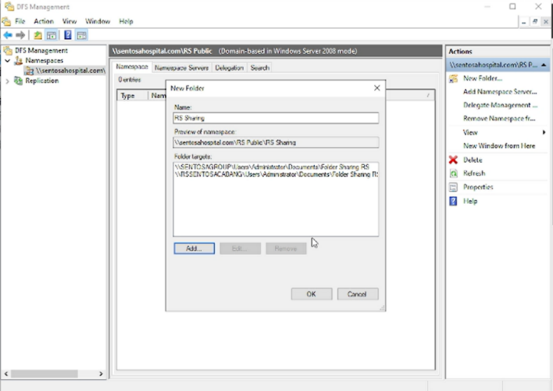 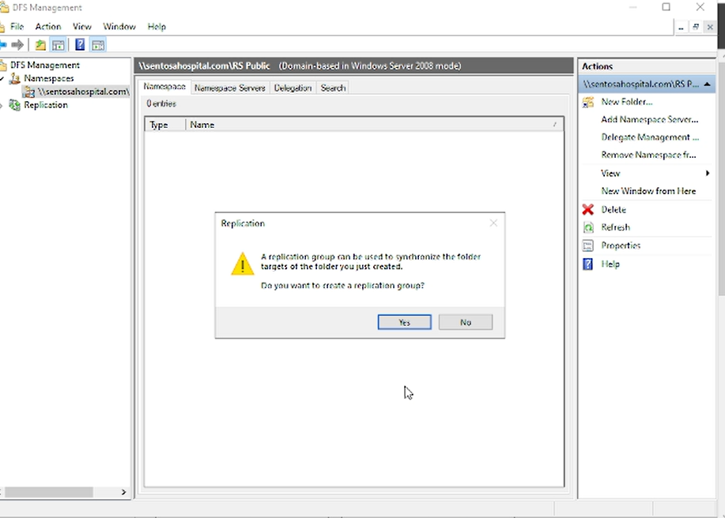

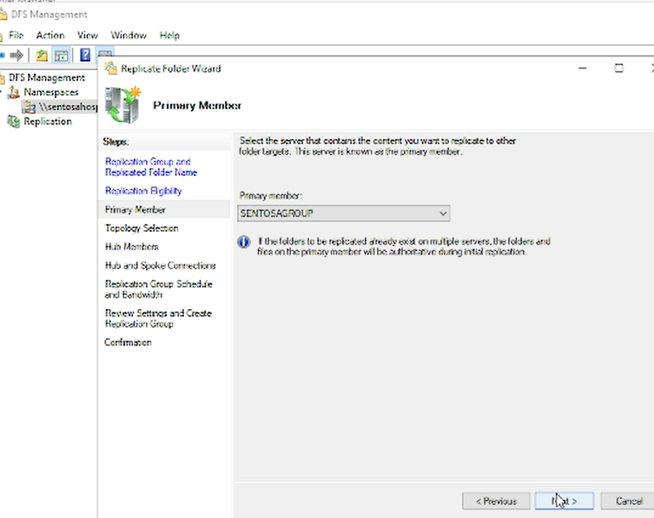 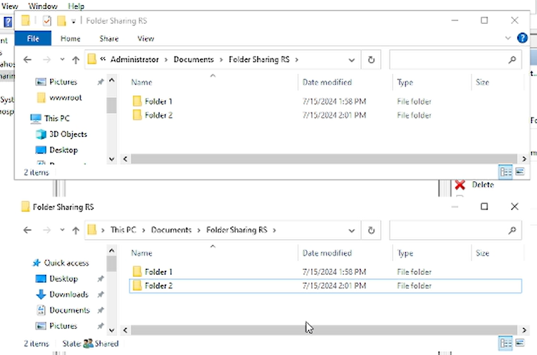

|  |
| --- |
| **REQUIREMENTS** |

|  |  |  |
| --- | --- | --- |
| **Hardware** :  1. Asus Laptop  **Operating System** :   1. Windows Server 64-bit   **Software** :   1. Oracle Virtual Box 2. Ms. Word 3. Power Point | | |
| **PROJECT FILE DETAILS** | | |
| No | Filename | Remarks |
| 1 | Grup 2 Project 4 FINAL.pdf | Paper File |
| 2 | Project 4 Presentation.ppt | Presentation File |